n SAP, parameters are used to set the configuration and define the functionality of an sap system like number of workprocesses, buffer size, locktable size etc.

Basically there are 2 types of parameters :

* Static
* Dynamic

Static are the parameters those won't take effect immediately the value is set. Restart of an sap system is required for them to take effect.

Dynamic are the parameters those will take effect immediately in the run time. Restart of an sap system is not required for them to take effect.

Parameter can be differentiated whether it is dynamic or static by checking in RZ11 transaction of SAP.

[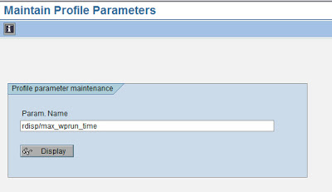](https://2.bp.blogspot.com/-8thHOPbzjFU/TfoQy0eIC0I/AAAAAAAAADw/GjNhLcNOpmc/s1600/dynamic1.jpg)

[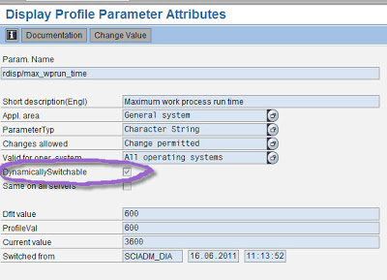](https://1.bp.blogspot.com/-Ka-EngirP6k/TfoQ0KIJn5I/AAAAAAAAAD0/nZmsAkUjZS0/s1600/dynamic2.jpg)

 In Rz11, type the parameter and display it. In the screen , there will be a check box with description as "Dynamically switchable". If that check box is ticked, it means that it is dynamic parameter and value can changed in run time without restart of the system. If it is not ticked, then it is static parameter and it needs restart of a sap system for the changes to take effect.   
  
In latest version SAP systems also, we can verify this through RZ11 tcode. Output might be bit different as shown below :

[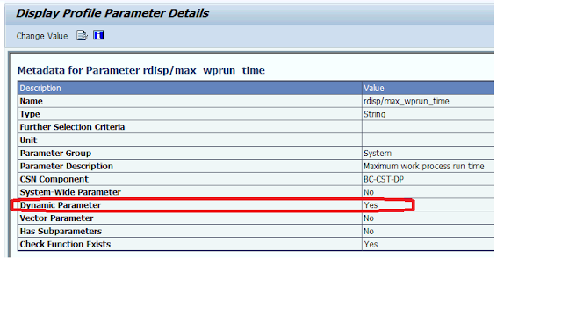](https://1.bp.blogspot.com/-43kGmARFMiI/XVX_t7YoVTI/AAAAAAAABQU/tp5wVJ2hRp0IK4-xU6j3HmQG3TqWT1PHQCLcBGAs/s1600/static1.png)

**How to change or set a SAP parameter**

SAP parameter can be set using RZ10 transaction. Go to RZ10, select the respective instance profile of the application server on which you would like to change the parameter.

From the dropdown of profile, select the instance profile (of the application server) on which you would like to change the parameter.

[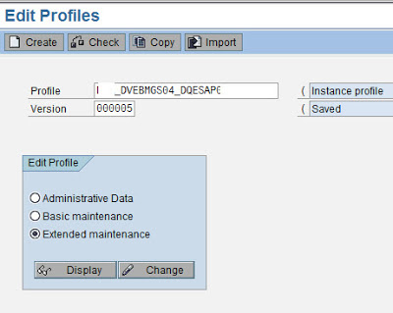](https://2.bp.blogspot.com/-iQNKkIVGkUc/Tfn12VyYWsI/AAAAAAAAABo/0gaRUTEeAeY/s1600/param1.jpg)

After selecting the profile, select extended maintenance button and press change push button.

It displays a screen with all the parameters as shown below :

[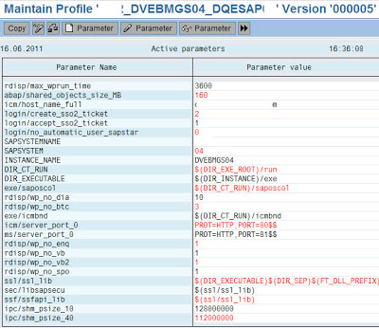](https://3.bp.blogspot.com/-w7hlGnwvy8k/Tfn14n8ecuI/AAAAAAAAABs/TvAABe9K96A/s1600/param2.jpg)

You can  either search the parameter or create the parameter and then set the value to the desired and save the same as below.

[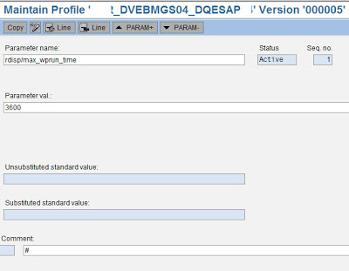](https://1.bp.blogspot.com/-J5WJdM0iMdw/Tfn164hCHBI/AAAAAAAAABw/6BakZysOj0g/s1600/pram3.jpg)

Set the parameter value in the text box provided and click copy button to copy the same and then press back button and press copy again in the next screen. After that press the back arrow to come to the following screen

[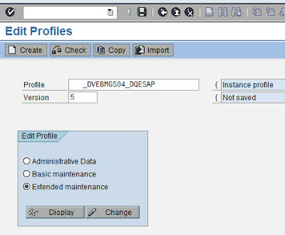](https://2.bp.blogspot.com/-NrjGvrRli84/Tfn18vRlDWI/AAAAAAAAAB0/tq-DUd68RTk/s1600/param4.jpg)

Click on Save button to save and activate the profile.

[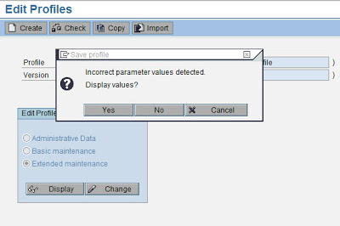](https://4.bp.blogspot.com/-Zv8ocAAJuxI/Tfn19_It4TI/AAAAAAAAAB4/NW3mvl_Mddg/s1600/param5.jpg)

Press no to goto the next screen

[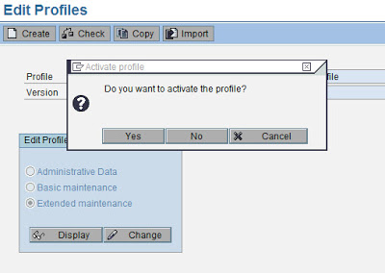](https://1.bp.blogspot.com/-vSF2Kx9eQlw/Tfn1-3IvqnI/AAAAAAAAAB8/8txCfsY5uAs/s1600/param6.jpg)

Press yes, to activate the profile.

[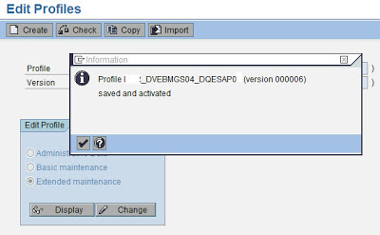](https://3.bp.blogspot.com/-jZq1rxQgiIw/Tfn2AARqojI/AAAAAAAAACA/CTyRrJ9bV0I/s1600/param7.jpg)

The parameter will take effect after restart of the application server

Through Rz11,

we can view the sap parameters default value, current value and profile parameter value. Default value means the value obtained after system setup. profile parameter value is the value present in RZ10 profiles. Current value means that value that is set for a parameter through Rz11 tcode(i.e. value set for a parameter dynamically).  
  
Through Rz11, we can set value for a some selected parameters and those values will be lost after restart of the application server and system again starts with values in profile.  
  
Through Rz10 transaction, we can set permanent values to a parameter,

whose values take effect only after restart of the application server as after restart profile file parameters will be read by server.  
  
To summarize, through Rz11 we can set values for dynamic parameters for temporary purpose and these values will be lost if application server is restarted. If you would like to change those values permenantly, we need to set through Rz10 and values take effect only after system restart.